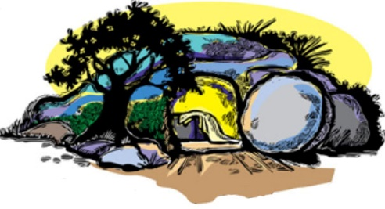
I BELIEVE IN THE RESURRECTION
2021 Great Lakes Region Spring Conference
Online at: utchristians.org/believe

Friday, April 9
7:00 pm  7:05 pm  7:10 pm  7:30 pm  7:40 pm  7:45 pm  7:50 pm  8:20 pm  8:25 pm  8:30 pm  8:45 – 10 pm | Welcome by Russell Kille  Zoom Host: Kirk Kayser  Prayer: Joshua Lee, Faith Bang  Chapter Introductions (2 minutes each)  Praise & Worship: John & Joanna Cha  Scripture Reading: Passage John 11:1-44 (Adira Reynolds)  Special Music: Myall family  Resurrection Message: Dr. Tom Kalapos  Responsive Song: Everyone (led by Grace Kim)  Announcements: Peter Park  Short Break (optional chair yoga led by Faith Bang)  Bible Study Break Out: 1 Corinthians 15:1-11

Saturday, April 10
1:00 – 1:30 pm | CBF Kids Space (led by Catie Pelland)
4:00 – 5:00 pm | Optional - Peer Group Fellowship Hangout
7:00 pm | Praise & Worship: Joshua & Sarah Lee
7:15 pm | Prayer: Joanna Cha Sr., Rebekah Kim  Zoom Host: Michael McWhorter
7:20 pm | By the Grace of God Life Testimonies: (7-10 min each)
 | Brandon Edwards., Chris Hoffman., Hanna Kang.
7:50 pm | Short Break
8:00 pm | Special Music: Erie PA, UBF
8:05 pm | Resurrection Testimonies (5 min each)
 | Amanda Sullivan, Curtis Rodriguez, A.J. Jordan
8:30 pm | Duet: Amanda & Cindy Sullivan
 | Announcements: Joshua Bang
8:45 – 10pm | Bible Study Groups: All share 1 page resurrection testimony.

Sunday, April 11
10:00 am | Praise & Worship: Toledo UBF
10:15 am | Prayer: Paul Choi, Joy Kim  Zoom Host: Toledo UBF
10:20 am | Scripture Reading: 1 Corinthians 15:1-11 (Toledo UBF family)
10:25 am | Harp Music: Joe Stasinos
10:30 am | Special Song: Charles Baker
10:35 am | Resurrection Message: Steve Stasinos
11:05 am | Responsive Song: Everyone (led by Ohene-Larbi family)
11:10 am | International Guest Speaker Bruno Aussant
11:20 am | Offering: Music: Kirk Kayer Prayer: Toledo UBF
11:30 am | Closing Remarks & Prayer Topics: Peter Park, Russell Kille

