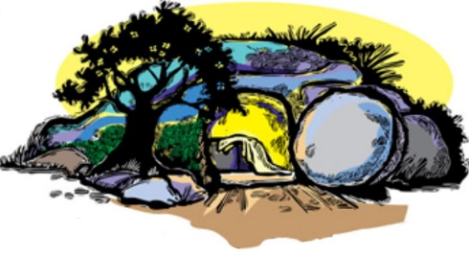

I BELIEVE IN THE RESURRECTION
2021 Great Lakes Region Spring Conference
April 9-11, 2021

We invite you to join to join with Christians from around the Great Lakes region for a time of spiritual fellowship and renewal. Our goal is to encourage one another as we consider the gospel of Jesus’ resurrection though fellowship, music, bible study, messages and personal testimonies. We pray that God may use this conference to open the way for you to meet Jesus personally and experience His resurrection power in your own life.

For times and details visit: utchristians.org/believe

University Bible Fellowship (UBF) is an international evangelical church (non-denominational) dedicated to Christ and his kingdom. Our goal is to bring glory to God through faithful obedience to His word in loving fellowship with each other. We especially pray to reach college students and help them grow as Jesus' disciples. www.ubf.org

I BELIEVE IN THE RESURRECTION
2021 Great Lakes Region Spring Conference
April 9-11, 2021

We invite you to join to join with Christians from around the Great Lakes region for a time of spiritual fellowship and renewal. Our goal is to encourage one another as we consider the gospel of Jesus’ resurrection though fellowship, music, bible study, messages and personal testimonies. We pray that God may use this conference to open the way for you to meet Jesus personally and experience His resurrection power in your own life.

For times and details visit: utchristians.org/believe

University Bible Fellowship (UBF) is an international evangelical church (non-denominational) dedicated to Christ and his kingdom. Our goal is to bring glory to God through faithful obedience to His word in loving fellowship with each other. We especially pray to reach college students and help them grow as Jesus' disciples. www.ubf.org

